Fixes List: Home Page Idiwtis V5
1. Title Symbol Alignment
Issue & Fix: The square symbol at the end of each heading must sit on the exact same line as the title text. On the first hero banner, adjust the layout so the red symbol does not drop to a second line.
Screenshot: 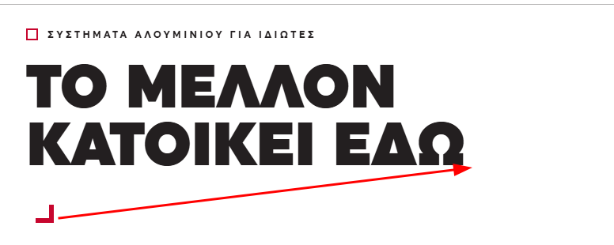
2. Remove Hyphens/Dashes in Copy
Issue & Fix: Remove hyphens/dashes from body text across the site, such as in the hero banner description. Replace them with a period or comma where appropriate. (Note: If possible, make all text layers fully editable/manageable so copy can be adjusted directly).
- Screenshot: 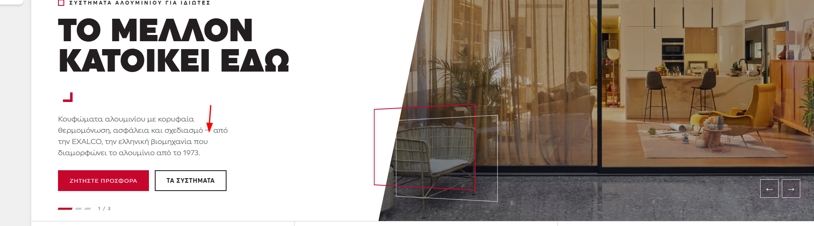
- 3. USP Section Numbers
- Issue & Fix: Change the color of number 03 in the USPs section from red to black, matching all the other numbers in the list.
- Screenshot:
- 4. Renovate Section Buttons
- Issue & Fix: Remove the CTA button "See if you qualify" ("Δείτε αν δικαιούστε"). Keep only "Request a Quote" ("Ζητήστε Προσφορά") and style it in red with an arrow (matching the visual style of the removed button).
- Screenshot:
- 5. Card Text & Badge Cleanup
- Issue & Fix: Remove the "ONLY 2 MINUTES" ("ΜΟΛΙΣ 2 ΛΕΠΤΑ") red badge, and remove the body copy below the card heading.
Screenshot: 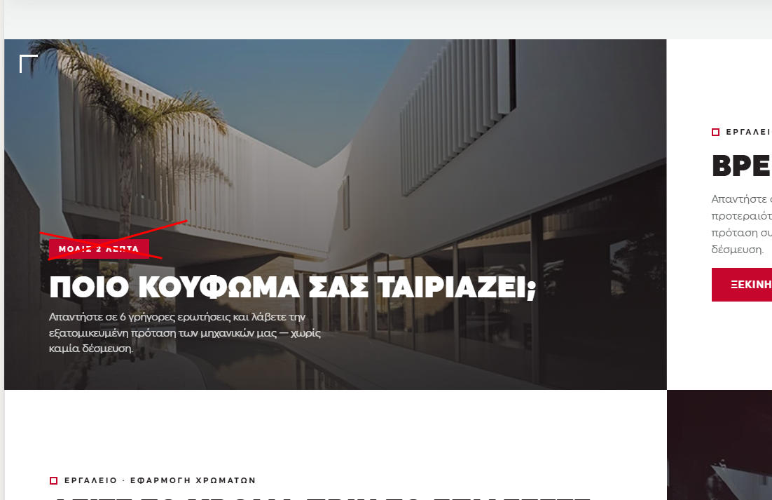
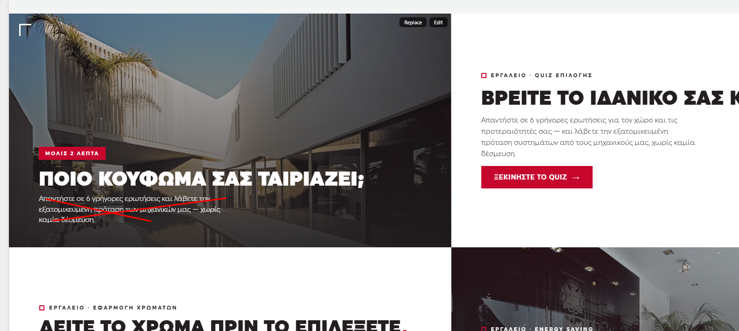

- 6. Tool Header Icon
- Issue & Fix: Replace the generic square icon next to "TOOL" ("ΕΡΓΑΛΕΙΟ") with the actual Quiz icon, so users instantly connect the concept visually.
- Screenshot: 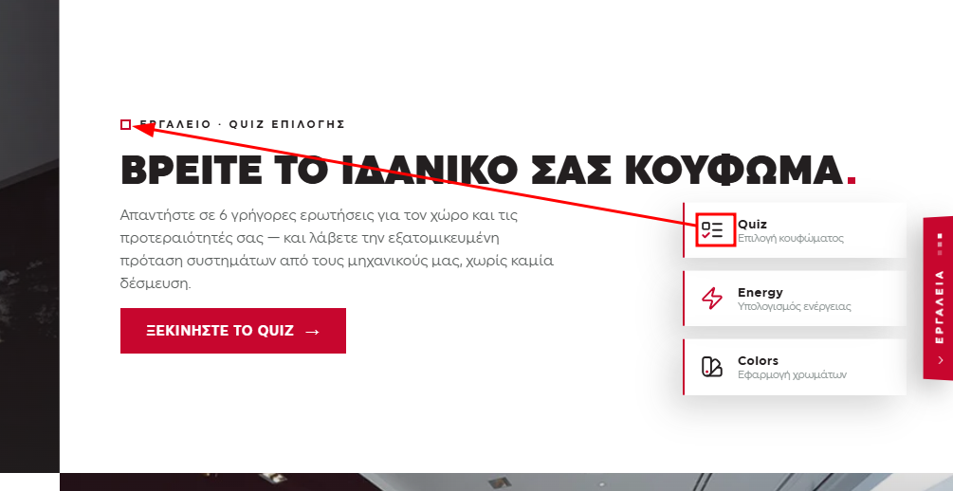
- 7. Copy Removal
- Issue & Fix: Remove the phrase "without any commitment" ("χωρίς καμία δέσμευση") from the copy across the page.
- Screenshot:
- 8. Icon Consistency Across Tools
- Issue & Fix: Replace the header icons across all tool cards (Quiz, Energy, Colors) with their matching icons from the sticky menu to maintain visual consistency throughout the interface.
- Screenshot: 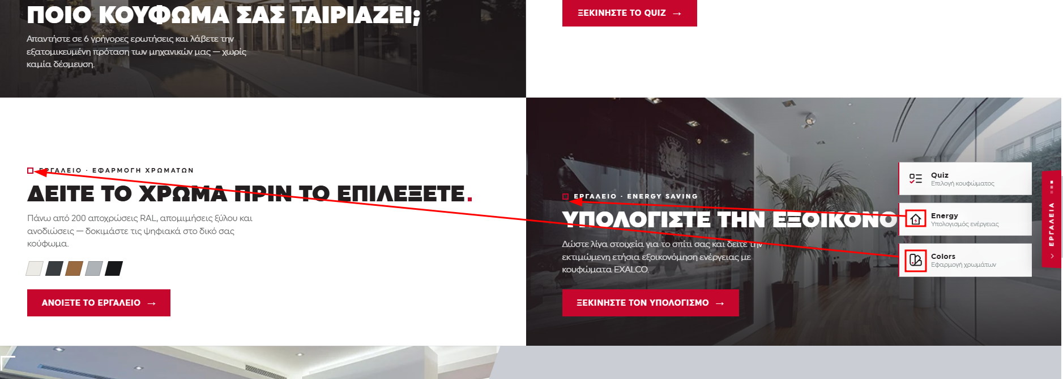
- 9. Projects Section CTA
- Issue & Fix: Add a CTA button in the Projects section that leads to the full list of projects (similar to the "All Articles" button in the blog section).
- Screenshot:
- 10. Article Cards CTA
- Issue & Fix: Add a "Read More" ("Δείτε περισσότερα") CTA link/button on each article card in the Articles section.
- Screenshot:
- 11. Footer Typography
- Issue & Fix: Set all text in the footer to white instead of gray for better contrast and readability.
- Screenshot:
- 12. Footer Navigation Links
- Issue & Fix: Remove the links "Tools" ("Εργαλεία") and "Library" ("Βιβλιοθήκη") from the footer, and replace them with "Quiz" and "Get a Quote" ("Πάρε Προσφορά").
- Screenshot:
- 13. Back to Top Button
- Issue & Fix: Add a "Back to Top" button featuring an inventive icon related to the industry (e.g., aluminum profiles, window frame, or architectural design element).
- Screenshot:

